Computer Workstation Self-Assessment Checklist

The following checklist is provided to assist you with setting up and assessing your own workstation ergonomics.

- Once you have completed the self assessment checklist, record any problems identified, corrective actions taken and recommendations in the relevant section and report these to your Supervisor /Line Manager. Allow yourself at least a week with your new set up to determine if you are gaining benefits from the changes.
- Provide a copy of this completed checklist to your Supervisor / Line Manager.
- Your supervisor should then complete the control plan and both of you should sign off on the assessment.
- You may need to ask your supervisor, a fellow staff member or a Workplace Health and Safety Officer (WHSO) for help in checking your posture whilst you make adjustments.

Name: ________________________________________ Date: __________________

Section 1: Daily tasks
Daily Tasks
Minimise tired muscles by taking frequent short breaks from an activity and by doing simple exercises during those breaks to aid recovery.
List your main daily tasks

Question | Yes/No | Possible Solutions
Are your daily tasks varied to help overcome repetitive and prolonged activities? |  | Break up long periods of continuous computer use by performing alternative tasks that require you to stand and walk away briefly from your computer.
Do you take rest breaks or short work pauses regularly? |  | Take regular short breaks to relax hand postures, look away from the computer or stand and stretch your legs.
Do you change your posture and stretch regularly? |  | Vary your posture as much as possible. Stand or walk about, or do some stretches at least every 30 minutes.
Actions taken (list any adjustments you have made) and Recommendations (what recommendations would you make to improve your workstation ergonomics?)

Section 2: Chair
Chair
Adjust your chair:
- Adjust chair height so that your elbows are by your side and level with the desk or slightly above the desk.
- Adjust the height of the backrest to support the inward curve in your lower back.
- The backrest angle is adjusted to a comfortable position, for most people this will be an upright or slightly reclined position (see images below for options for varying sitting postures).
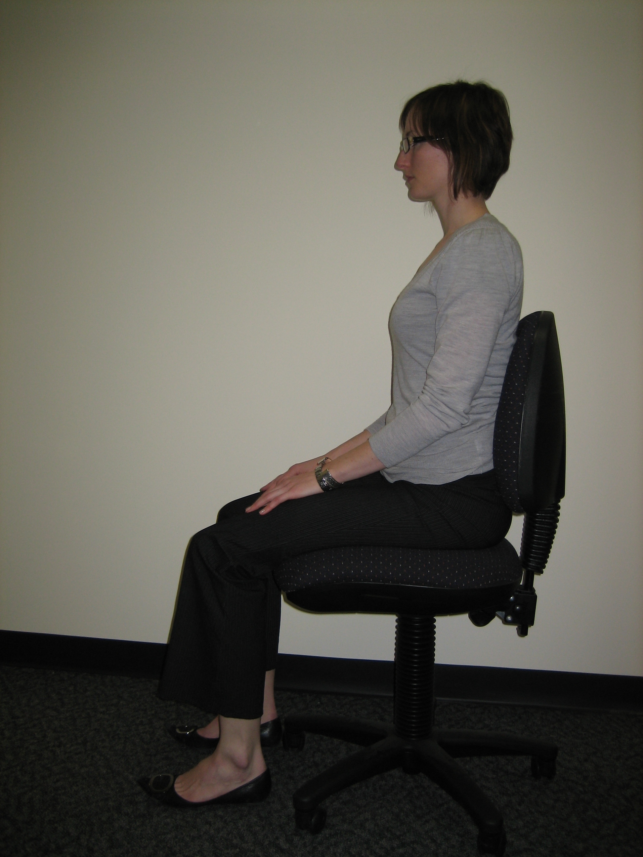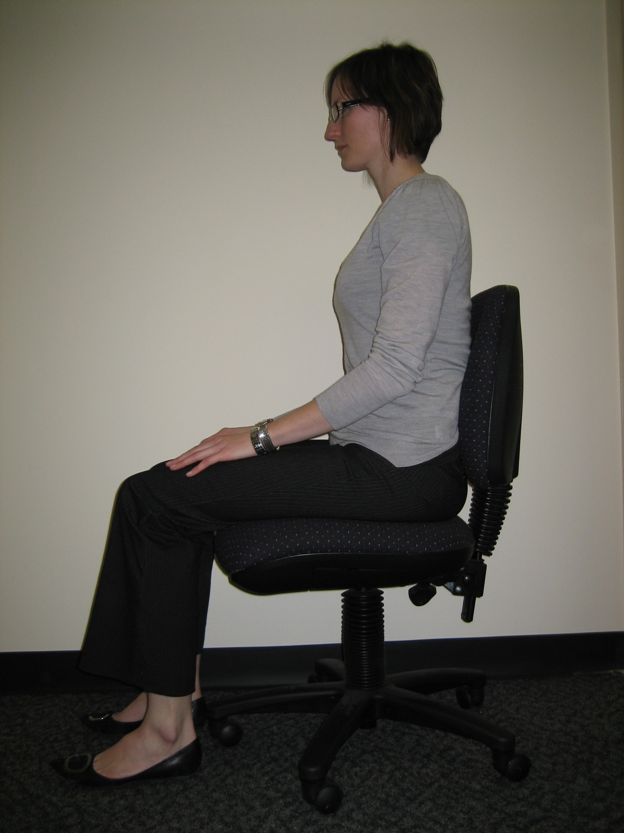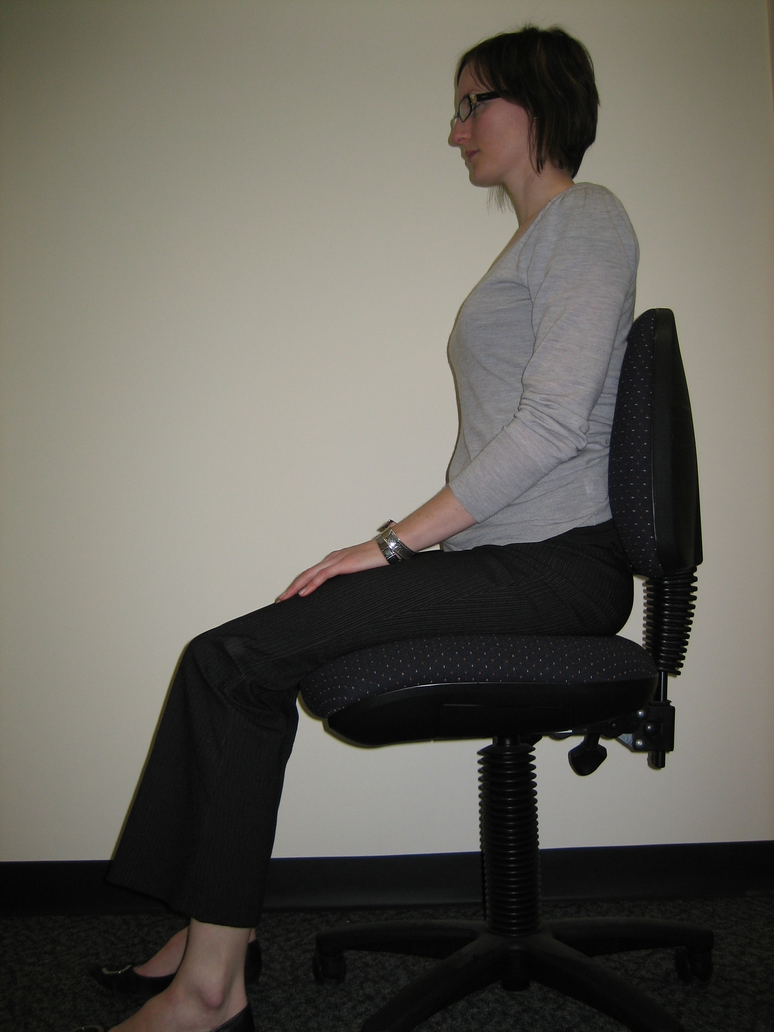
- If your feet are not flat on the floor, use a footrest.
Question | Yes/No | Possible Solutions
Are your feet on the floor or foot rest so that your knees are at 90° (right angles) and hips slightly above the knees? |  | Provide a footrest.  Adjust back rest angle or seat tilt angle.
Is your bottom well back in the seat with your lumbar spine (lower back) supported? |  | Adjust the backrest of your chair to support the curve in your lower back.  If your chair does not adequately support your lower back after adjusting it, provide an alternative chair* that supports your lower back.
Do you have adequate leg support so that 2-3 fingers fit between the chair and the back of your knee? |  | If the seat is too deep – provide an alternative chair* with a shorter seat pan.  If the seat is too shallow – provide an alternative chair* with a longer seat pan.
Can you get close to the workstation without hindrance? |  | Remove the arm rests.  Provide a chair with adjustable height arm rests.
Counter work – Is there a chair appropriate for sit/stand work? |  | Provide a sit stand stool or high ‘counter / drafting’ type office chair, with a foot support ring.
Actions taken (list any adjustments you have made) and Recommendations (what recommendations would you make to improve your workstation ergonomics?)
* Discuss options for a more detailed seating assessment with your Supervisor/Line Manager.

Name: ________________________________________ Date: __________________

Section 3: Desk
Desk
Position frequently used items within easy reach on your desk top.
Question | Yes/No | Possible Solutions
Is there sufficient room on your desk to set up your computer correctly? |  | Remove clutter from your desk to allow adequate workspace.
Are frequently used items within comfortable reach? |  | Rearrange your desk so that frequently used items are closer.
Is the area underneath your desk free from stored items that would reduce leg room and freedom of movement? |  | Do not store items under the desk - this will affect the leg clearance at the workstation.
Actions taken (list any adjustments you have made) and Recommendations (what recommendations would you make to improve your workstation ergonomics?)

Section 4: Monitor
Monitor
Position your monitor directly in front of you, with the monitor approximately one arm’s length away from you. The top of the monitor should be level with or slightly below eye level to avoid having to tilt the head back to look up at the screen. (N.B. If you wear bifocals you will need the screen lower).
Question | Yes/No | Possible Solutions
Is the top of the monitor (toolbar) at eye level when you are seated in the chair and looking straight ahead? (get someone to check while you are keying) |  | Adjust monitor height.  Discuss the need for task specific spectacles with your Optometrist.
Is the monitor located directly in front of you at approximately an arm’s distance when seated? |  | Reposition the monitor on the desk.
Is there glare on the screen? |  | Reduce glare by re-positioning the monitor parallel to the windows, decreasing overhead lighting, using window shades, tilting the screen or using an anti-glare filter.
Actions taken (list any adjustments you have made) and Recommendations (what recommendations would you make to improve your workstation ergonomics?)

Name: ________________________________________ Date: __________________

Section 5: Document Holder
Document Holder
Position your document holder between the keyboard and monitor or beside the monitor at the same height as the screen, so as to avoid bending or twisting the neck.
Question | Yes/No | Possible Solutions
Do you spend a large proportion of your day transcribing from paper documents to the computer? |  | Provide a document holder.
Actions taken (list any adjustments you have made) and Recommendations (what recommendations would you make to improve your workstation ergonomics?)

Section 6: Keyboard and Mouse
Keyboard and Mouse
- Position your keyboard directly in front of you.
- The keyboard should be a comfortable distance from the edge of the desk to allow the forearms to be supported.
- Your mouse should be as close as possible to the edge of the keyboard.
- When using the keyboard & mouse, keep your wrists straight and shoulders relaxed.
Question | Yes/No | Possible Solutions
Is your keyboard positioned centrally in front of you and in-line with the monitor? |  | Reposition the keyboard on the desk.
Is the keyboard at a comfortable distance from the edge of your desk? |  | Position keyboard to allow the forearms to be supported.
Is your forearm supported on the desktop when using the keyboard and mouse? |  | Position the keyboard flat or only slightly sloped to avoid a cocked wrist position.
Is the mouse as close as possible to the edge of the keyboard? |  | Position the mouse as close to and preferably level with the keyboard.
Do you use keyboard shortcuts to reduce mouse use? |  | Consider using keyboard shortcuts to minimise time spent using the mouse.
Actions taken (list any adjustments you have made) and Recommendations (what recommendations would you make to improve your workstation ergonomics?)

Name: ________________________________________ Date: __________________
Section 7: Telephone Use
Telephone Use
Repeatedly reaching for the telephone which is too far away may result in strain on the shoulder, neck and arm. Do not cradle the telephone between your head and shoulder.
Question | Yes/No | Possible Solutions
Is your telephone in an ideal position on your desk? |  | Keep the telephone close at hand so that you can reach without stretching
Do you spend a large proportion of your day on the telephone whilst simultaneously writing or keying? |  | Avoid tilting the head/neck to cradle the telephone on your shoulder.  Use your hand to hold the receiver.  Use a headset or the speaker function.
Actions taken (list any adjustments you have made) and Recommendations (what recommendations would you make to improve your workstation ergonomics?)

Section 8: Laptop
Laptop
Laptop computers are intended to be used for short periods of time.
Question | Yes/No | Possible Solutions
Is your laptop only used for short periods of time (less than one hour?) |  | If using for long periods (i.e. over 2 hours) then it is recommended that the laptop be used with:  - A docking station, separate monitor, keyboard and mouse; or  - A laptop stand (to raise the height of the screen), separate keyboard and mouse.
Actions taken (list any adjustments you have made) and Recommendations (what recommendations would you make to improve your workstation ergonomics?)

Additional Notes/Comments/Questions: (if you think of anything extra during your self assessment note them below to discuss with your Supervisor or Occupational Health and Safety Officer)

Name: ________________________________________ Date: __________________
Date of self-evaluation
Surname |  | Given Names
Position Title |  | Class/Level
Dept/Location |  | Contact No
Supervisor / Line Manager |  | Contact No

Where hazards or risks have been identified, complete the following control plan:
Control Plan
Recommendation/Control  What needs to be done | Approved by | Date to be implemented | Whose responsibility | Planned review date
Acknowledgment of Assessment and Recommendations

___________________________ ___________________________
Employee’s Signature Line Manager’s Signature

___________________________ ___________________________
Employee’s Name Line Manager’s Name

Date: _____ / _____ / _____ Date: _____ / _____ / _____

Responsibility
It is the responsibility of the work area to organise and implement the agreed recommendations/ controls. If you need further assistance to evaluate your workstation, discuss with your Supervisor/Line Manager options for a more detailed assessment.
Monitor & Review
Once agreed recommendations have been implemented, Supervisors/Line Managers should review and monitor these to check their effectiveness and to identify if any new concerns have arisen.
Review date | Outcome of review  Comment on effectiveness of controls, outstanding recommendations or any new concerns | Review completed by

