

**Safe Hands**

**Quick Exposure Check** (QEC)

Specific Task Manual Handling Assessment

Task being assessed:

Assessment conducted by: Date: Time:

Action(s) required:

Acceptance signature of Senior Line Manager responsible for the task:

Date:

(The term “Senior Line Manager” refers to a manager who does not share the responsibility of the area/ machine with another manager of equal level.)

Specific Task Manual Handling Assessment Scoring

*Please tick the relevant boxes*

**A: When performing the task, is the back**

*(select worse case situation)*

◻ A1 Almost neutral (i.e. inline with legs)

◻ A2 Moderately flexed or twisted or side bent?

◻ A3 Excessively flexed or twisted or side bent?

**B: Select ONLY ONE of the two following task options:**

**ER**

**For seated or standing stationary tasks. Does the**

**back remain in a static position most of the time?**

◻ B1 No

◻ B2 Yes

**OR**

**OR**

**For lifting, pushing/pulling and carrying tasks**

**(i.e. moving a load). Is the movement of the back**

◻ B3 Infrequent (around 3 times per minute or less)?

◻ B4 Frequent (around 8 times per minute)?

◻ B5 Very frequent (around 12 times per minute or more)?

**C: When the task is performed, are the hands**

*(select worse case situation)*

◻ C1 At or below waist height?

◻ C2 At about chest height?

◻ C3 At or above shoulder height?

**D: Is the shoulder/arm movement**

◻ D1 Infrequent (some intermittent movement)?

◻ D2 Frequent (regular movement with some pauses)?

◻ D3 Very frequent (almost continuous movement)?

**E: Is the task performed with** *(select worse case situation)*

◻ E1 An almost straight wrist?

◻ E2 A deviated or bent wrist?

**F: Are similar motion patterns repeated**

◻ F1 10 times per minute or less?

◻ F2 11 to 20 times per minute?

◻ F3 More than 20 times per minute?

**G: When performing the task, is the head/neck**

**bent or twisted?**

◻ G1 No

◻ G2 Yes, occasionally

◻ G3 Yes, continuously

**H: Is the maximum weight handled in this task?**

◻ H1 Light (5 kg or less)

◻ H2 Moderate (6 to 10 kg)

◻ H3 Heavy (11 to 20kg)

◻ H4 Very heavy (more than 20 kg)

**J: On average, how much time is spent per day on this task by one person?**

◻ J1 Less than 2 hours

◻ J2 2 to 4 hours

◻ J3 More than 4 hours

**K: When performing this task, is the maximum force level exerted by one hand?**

◻ K1 Low (e.g. less than 1 kg)

◻ K2 Medium (e.g. 1 to 4 kg)

◻ K3 High (e.g. more than 4 kg)

**L: Is the visual demand of this task**

◻ L1 Low (almost no need to view fine details)?

◻ **\***L2 High (need to view some fine details)?

**\*** *If High, please give details in the box below*

Back

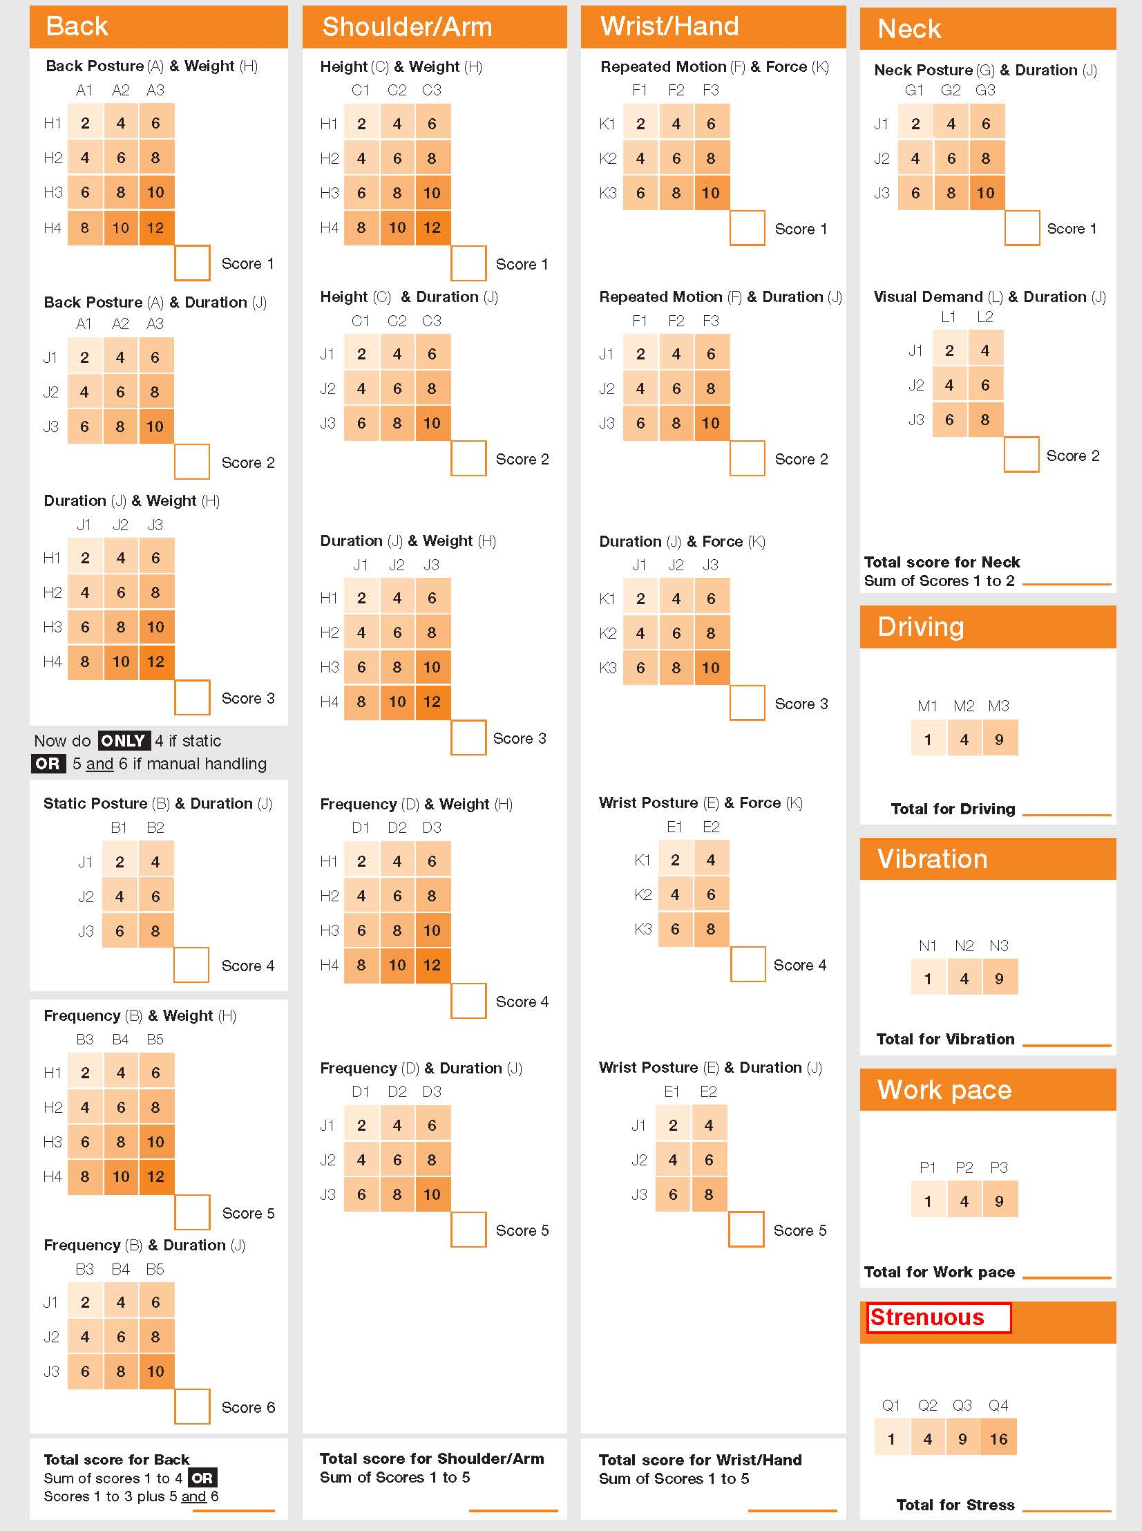

Neck

**Interpreting the scores**

**Exposure scores for body areas**

The total score for each body area is determined from the interactions between the exposure levels for the relevant

risk factors (see table below), and their subsequent addition.

It is important to take note of which interactions contribute most to the overall score for each body area.

The exposure scores for the back, shoulder/arm, wrist/hand and neck have been categorised into 4 exposure categories: Low, Moderate, High or Very High. Even if the exposure score is Low, it is important to note

that one or two interactions may be contributing disproportionately to the score (i.e. a score of 8 or more).

For Moderate, High and Very High scores, there are likely to be several interactions that should be identified and

reduced. It is also possible that one or two interactions are at the highest levels (i.e. 10 or 12) of exposure. These

should be addressed urgently to reduce the level of exposure for these factors.

These interactions should be monitored and reviewed as injury to the body could occur if exposure continues.

Where scores are Moderate or High, or Very High, the level of exposure should be reduced.

Important risk factors

Important Risk Factors

|  |  |  |  |
| --- | --- | --- | --- |
| **Back** | **Wrist/hand** | **Neck** | **Shoulder/arm** |
| • load weight | • force | • duration | • load weight |
| • duration | • duration | • posture | • duration |
| • frequency of movement | • frequency of movement | • visual demand | • task height |
| • posture | • posture |  | • frequency of movement |

Exposure level

Exposure Level

|  |  |  |  |  |
| --- | --- | --- | --- | --- |
| **Score** | **Low** | **Moderate** | **High** | **Very High** |
| **Back (static)** | 8-15 | 16-22 | 23-29 | 29-40 |
| **Back (moving)** | 10-20 | 21-30 | 31-40 | 41-56 |
| **Shoulder/ arm** | 10-20 | 21-30 | 31-40 | 41-56 |
| **Wrist/ hand** | 10-20 | 21-30 | 31-40 | 41-46 |
| **Neck** | 4-6 | 8-10 | 12-14 | 16-18 |

Exposure level