The following checklist is provided to assist you with setting up and assessing your own workstation ergonomics.

- Once you have completed the self assessment checklist, record any problems identified, corrective actions taken and recommendations in the relevant section and report these to your Supervisor/Manager. Keep your new set-up for at least a week before deciding on making further changes.
- Provide a copy of this completed checklist to your Supervisor / Manager.
- Your supervisor should then complete the control plan and both of you should sign off on the assessment.
- You may need to ask your supervisor, or a fellow staff member for help in checking your posture whilst you make adjustments.

Name: ________________________________________ Date: __________________

Section 1: Daily tasks
Daily Tasks
Minimise tired muscles by taking frequent short breaks from an activity and by doing simple exercises during those breaks to aid recovery.
List your main daily tasks

Question | Y/N | Possible Solutions
Are your daily tasks varied to help overcome repetitive and prolonged activities? |  | Break up long periods of continuous computer use by performing alternative tasks that require you to stand and walk away briefly from your computer.
Do you take rest breaks or short work pauses regularly? |  | Take regular short breaks to relax hand postures, look away from the computer or stand and stretch your legs.
Do you change your posture and stretch regularly? |  | Vary your posture regularly. Stand, walk about, or stretch at least every 30 minutes. Feelings of tightness/soreness/fatigue are a sign you have been in one position too long
Actions taken (list any adjustments you have made) and Recommendations (what would improve your workstation ergonomics?)

Section 2: Chair
(Information on how to adjust your chair is available in the documentation that came with the chair or from the manufacturer’s website. It is possible that your chair has more adjustability than you realise)
Chair
Adjust your chair for comfort. While this allows for your individual needs, this generally means:
- A chair height that brings your elbows (when by your side) level with the desk or slightly above the desk.
- The backrest is positioned to support the inward curve in your lower back.
- The backrest angle is upright or slightly reclined
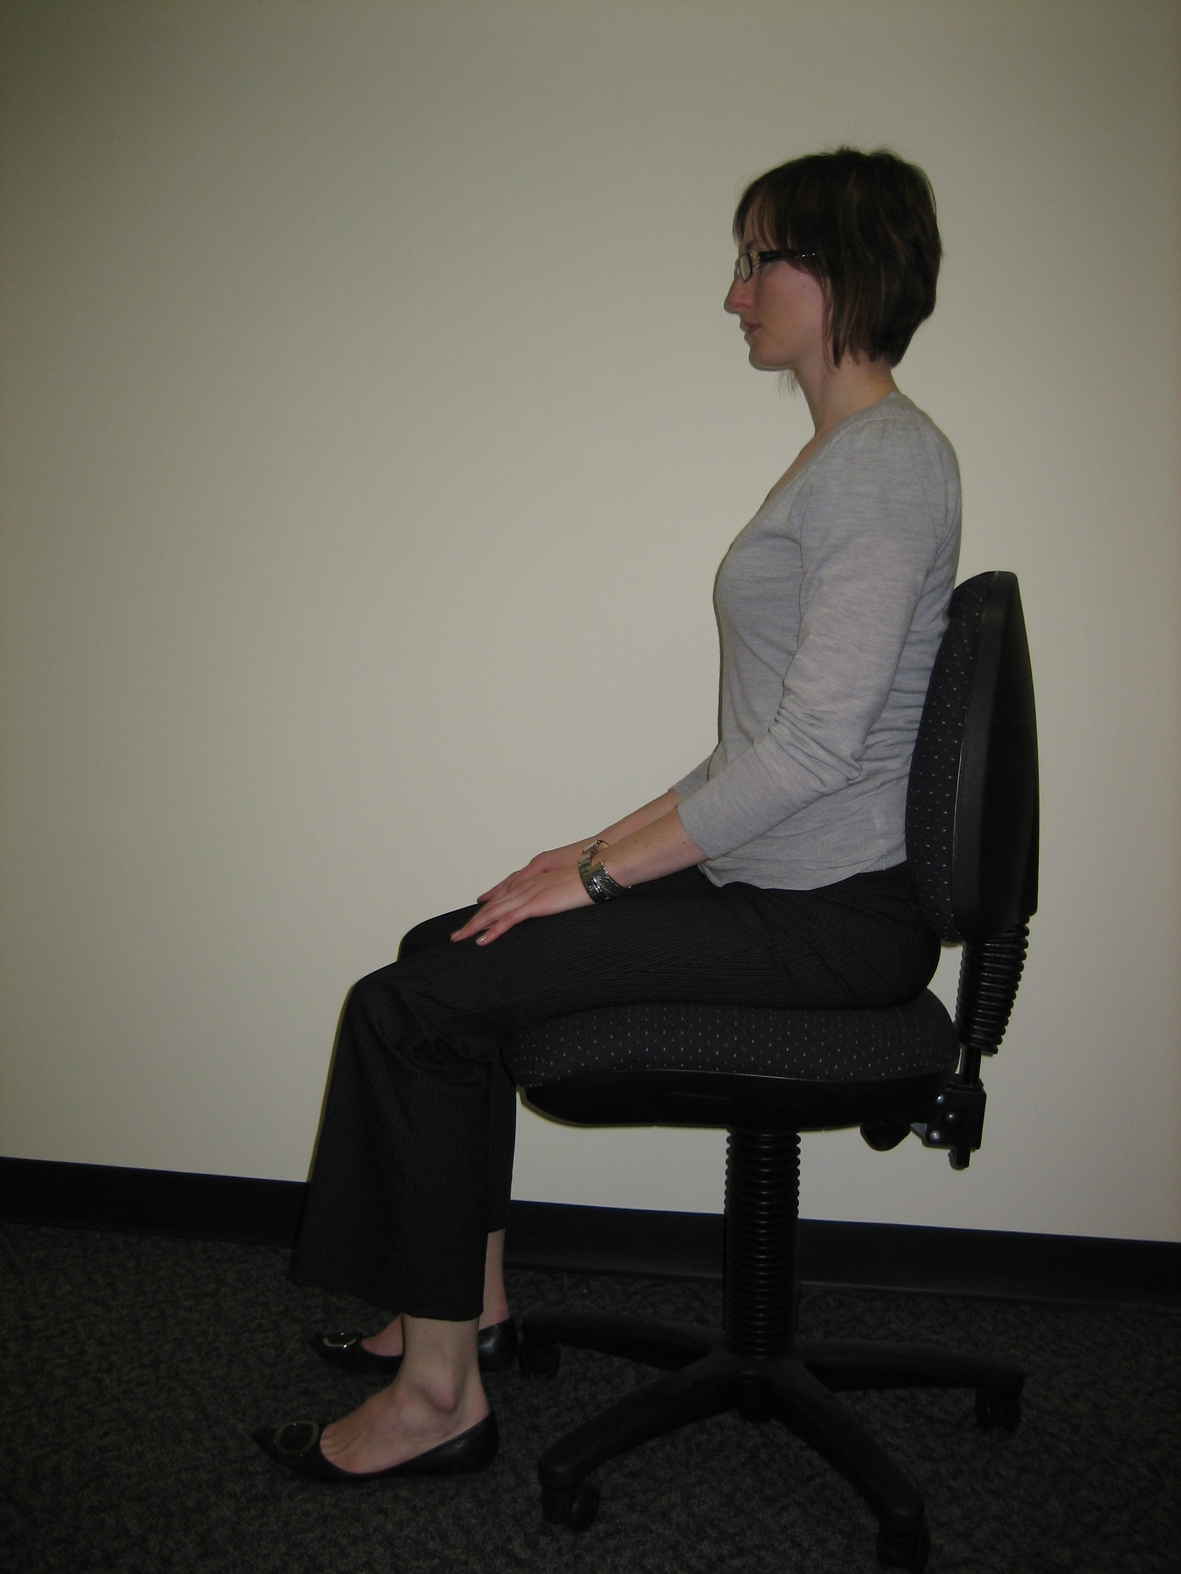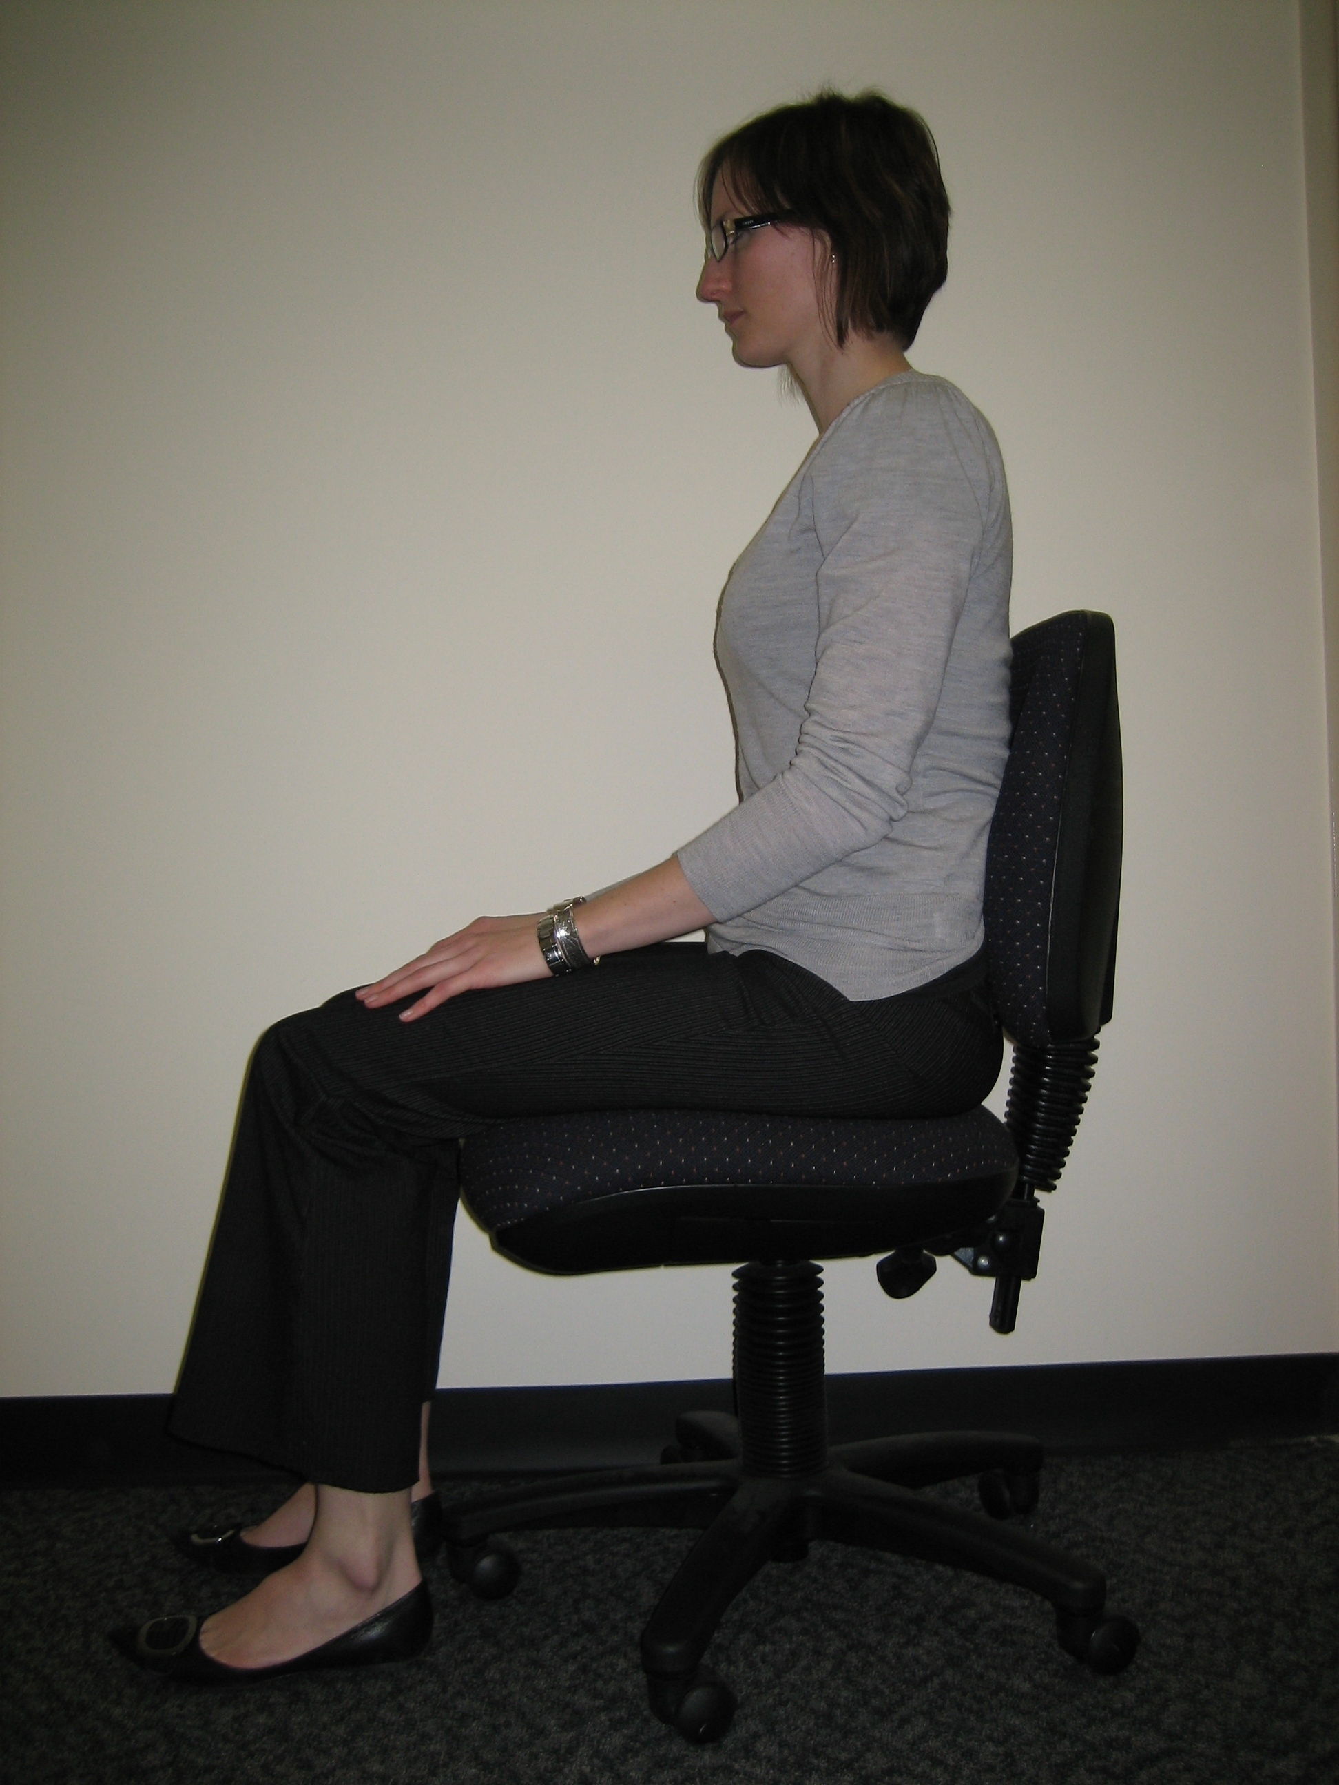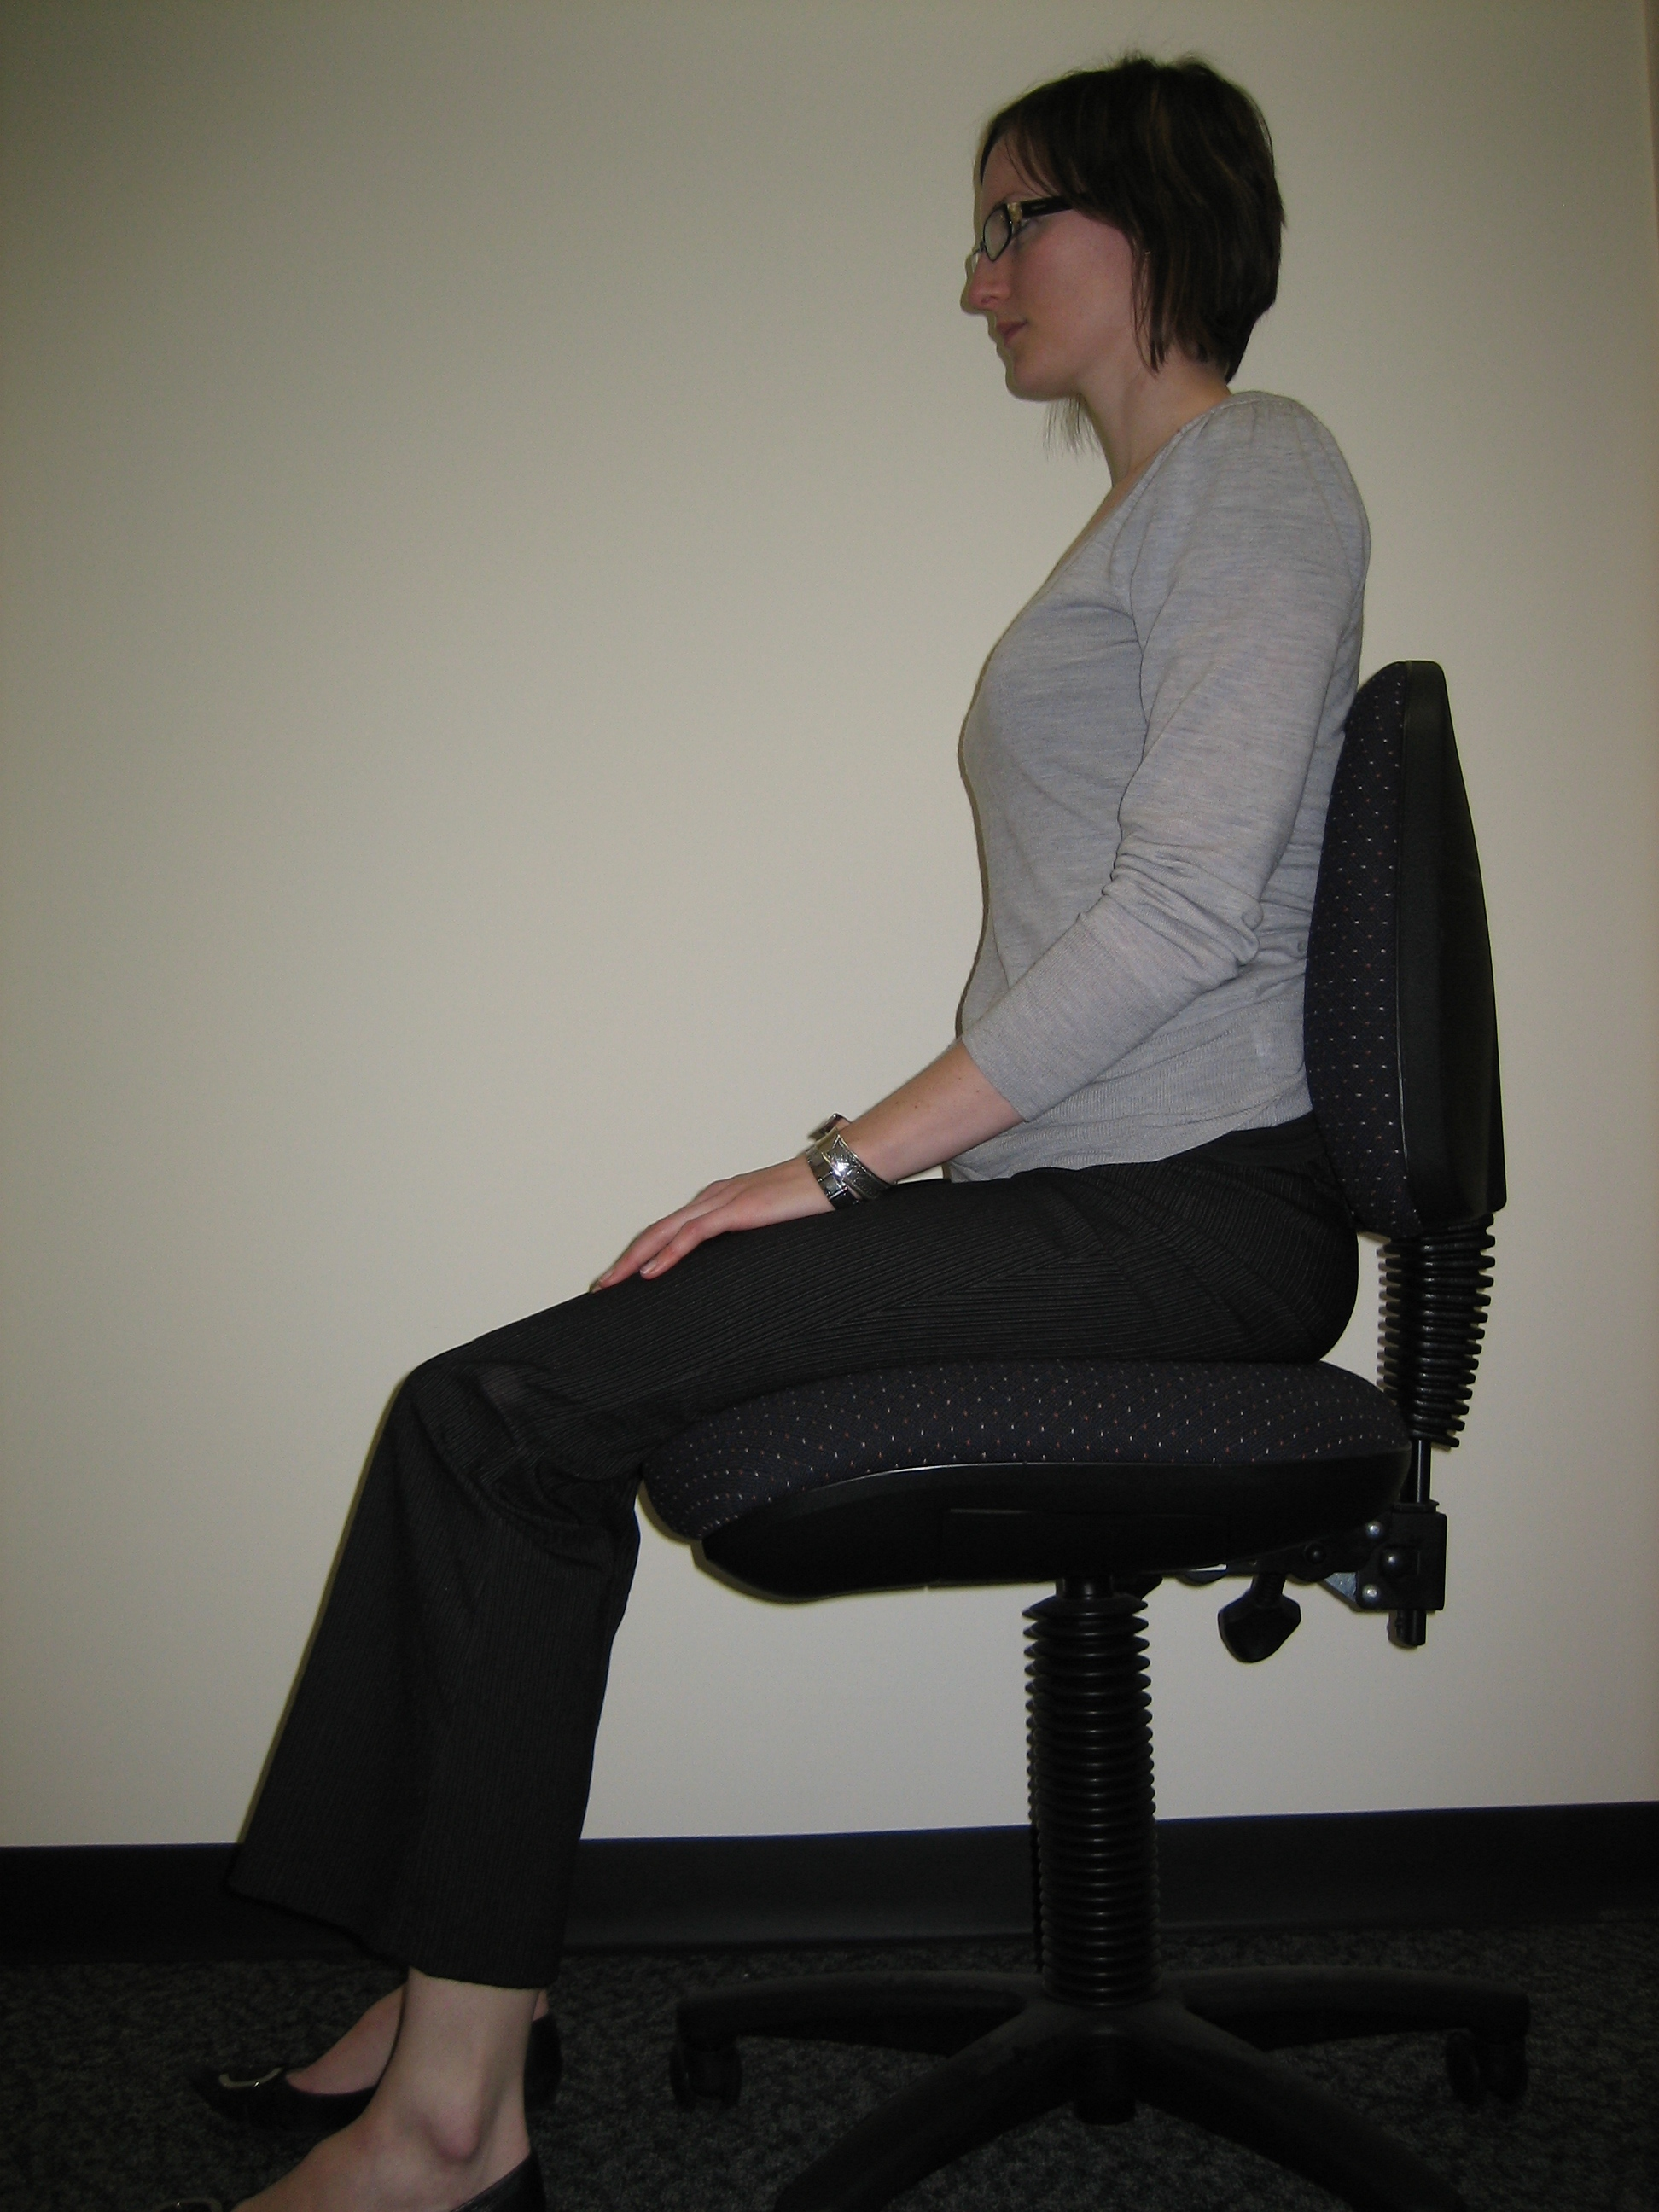
- Some chairs allow you to tilt the seat pan, slide it back and forward, or allow for the seat tilt to be locked or free to rock backwards and forward. .
- If your feet are not flat on the floor, use a footrest (commercial footrests are preferable to boxes).
Question | Y/N | Possible Solutions
Are your feet on the floor or foot rest so that your knees are at 90° (right angles) and hips slightly above the knees? |  | Provide a footrest.  Adjust back rest angle or seat tilt angle.
Is your bottom well back in the seat with your lumbar spine (lower back) supported? |  | Adjust the backrest of your chair to support the curve in your lower back.  If adjusting it doesn’t provide the required support, an alternative chair or a backrest insert may provide a solution.
Is the seat depth appropriate? (2-3 fingers should fit between the chair and the back of your knee) |  | Seek an alternative chair with a seat pan that meets your needs.  If the seat is too deep, a commercial backrest insert may bring you far enough forward to provide the clearance you need
Can you get close to the workstation without hindrance? |  | Remove the arm rests.  Provide a chair with adjustable height arm rests.
Counter work – Is there a chair appropriate for sit/stand work? |  | Provide a sit stand stool or high ‘counter / drafting’ type office chair, with a foot support ring.
Actions taken and Recommendations

Section 3: Desk
Height adjustable desks are expensive but can be an option if the desk has multiple users
Desk
Position frequently used items within easy reach on your desk top.
Question | Y/N | Possible Solutions
Is there sufficient room on your desk to set up your computer correctly? |  | Remove clutter from your desk to allow adequate workspace.
Are frequently used items within comfortable reach? |  | Rearrange your desk so that frequently used items are closer.
Is the area underneath your desk free from stored items that would reduce leg room and freedom of movement? |  | Tie all cables and cords out of the way. Avoid storing items under the desk. If your computer box is placed here, ensure you have sufficient clearance for your legs
Actions taken and Recommendations

Section 4: Computer/Monitor
Monitor
Position directly in front of you, with the screen approximately one arm’s length away. The top of the monitor should be level with or slightly below eye level to avoid having to tilt the head back to look up at the screen. (N.B. If you wear bifocals you will need the screen lower).
Computer
Place the box in a place which is easy to access the DVD drive and the USB ports but which also does not take up too much valuable desk space or restrict leg room under the desk.
There are also computer designs which can help to maximise space, with some examples below.
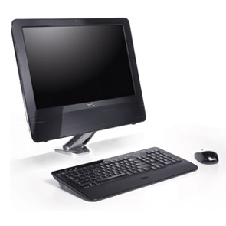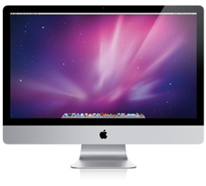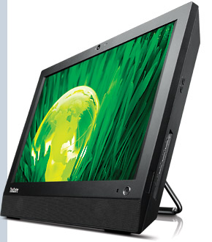
Dell Vostro 320 Apple iMac Lenovo A70z
Question | Y/N | Possible Solutions
Is the top of the monitor at eye level when you are seated and looking straight ahead? (get someone to observe you) |  | Adjust monitor height.  Discuss the need for task specific spectacles with your Optometrist.
Is the monitor located directly in front of you at approx. an arm’s length away? |  | Reposition the monitor on the desk.
Is there glare on the screen? |  | Re-positioning the monitor parallel to windows, decrease overhead lighting, use window shades, tilt the screen or use an anti-glare filter.
Is your computer hardware taking up space you need on the desk top? |  | Look at alternate computer designs, including wireless mouse and keyboards.  Look at networking options which mean you don’t need as much hardware on your desk
Actions taken and Recommendations

Section 5: Document Holder
Document Holder
Position your document holder between the keyboard and monitor or beside the monitor at the same height as the screen, to avoid bending or twisting the neck.
Question | Y/N | Possible Solutions
Do you spend a large proportion of your day transcribing from paper documents? |  | Provide a document holder.
Actions taken and Recommendations

Section 6: Keyboard and Mouse
Keyboard and Mouse
- Position your keyboard directly in front of you.
- The keyboard should be a comfortable distance from the edge of the desk.
- Your mouse should be as close as possible to the edge of the keyboard.
- When using the keyboard & mouse, keep your wrists straight and shoulders relaxed.
Question | Y/N | Possible Solutions
Is your keyboard positioned centrally in front of you and in-line with the monitor? |  | Reposition the keyboard on the desk.
Is the keyboard at a comfortable distance from the edge of your desk? |  | Position keyboard to allow the forearms to be supported.
Is your forearm supported on the desktop when using the keyboard and mouse? |  | Position the keyboard flat or only slightly sloped to avoid a cocked wrist position.
Is the mouse as close as possible to the edge of the keyboard? |  | Position the mouse as close to and preferably level with the keyboard.
Do you use keyboard shortcuts to reduce mouse use? |  | Consider using keyboard shortcuts to minimise time spent using the mouse.
Actions taken and Recommendations

Section 7: Telephone Use
Telephone Use
Repeatedly reaching for the telephone which is too far away may result in strain on the shoulder, neck and arm. Do not cradle the telephone between your head and shoulder.
Question | Y/N | Possible Solutions
Is your telephone in an ideal position on your desk? |  | Keep the telephone close at hand so that you can reach without stretching
Do you spend a large proportion of your day on the telephone whilst simultaneously writing or keying? |  | Avoid tilting the head/neck to cradle the telephone on your shoulder.  Use your hand to hold the receiver.  Use a headset or the speaker function.
Actions taken (list any adjustments you have made) and Recommendations (what recommendations would you make to improve your workstation ergonomics?)

Section 8: Laptop
Laptop
Laptop computers are intended to be used for short periods of time.
Question | Y/N | Possible Solutions
Is your laptop only used for short periods of time (less than one hour?) |  | If using for long periods (i.e. over 2 hours) then it is recommended that the laptop be used with:  - A docking station, separate monitor, keyboard and mouse; or  - A laptop stand (to raise the height of the screen), separate keyboard and mouse.
Actions taken (list any adjustments you have made) and Recommendations (what recommendations would you make to improve your workstation ergonomics?)

Additional Notes/Comments/Questions: (if you think of anything extra during your self assessment note them below to discuss with your Supervisor or Occupational Health and Safety Officer)

Date of self-evaluation
Surname |  | Given Names
Dept/Location |  | Contact No
E-mail address |  | Supervisor / Line Manager

Where hazards or risks have been identified, complete the following control plan:
Control Plan
Recommendation/Control  What needs to be done | Approved by | Date to be implemented | Whose responsibility | Planned review date
Acknowledgment of Assessment and Recommendations

___________________________ ___________________________
Employee’s Signature Manager’s Signature

___________________________ ___________________________
Employee’s Name Manager’s Name

Date: _____ / _____ / _____ Date: _____ / _____ / _____

Responsibility
It is the responsibility of the work area to organise and implement the agreed recommendations/ controls. If you need further assistance to evaluate your workstation, discuss with your Supervisor/ Manager options for a more detailed assessment.
Monitor & Review
Once agreed recommendations have been implemented, Supervisors/ Managers should review and monitor these to check their effectiveness and to identify if any new concerns have arisen.
Review date | Outcome of review  Comment on effectiveness of controls, outstanding recommendations or any new concerns | Review completed by

